**Video Link:**

https://deakin.au.panopto.com/Panopto/Pages/Viewer.aspx?id=1d091864-a904-4d7a-b3a7-b2ea00e558b5

**Screenshots:**

Sign in Page (currently not supporting signup feature, access via Google Gmail Account – Oauth protocol)

Main Dashboard of the website (allowing user to create a task through inputs, edit an existing task and delete that task)

Cloud Firestore Database (tasks are added to this database, each task is stored as a document with information come from input and from the userId which is the login Gmail Account)

GKE Cluster & Node (currently using zonal instead of regional standard cluster, and 1 node is being used at the moment)

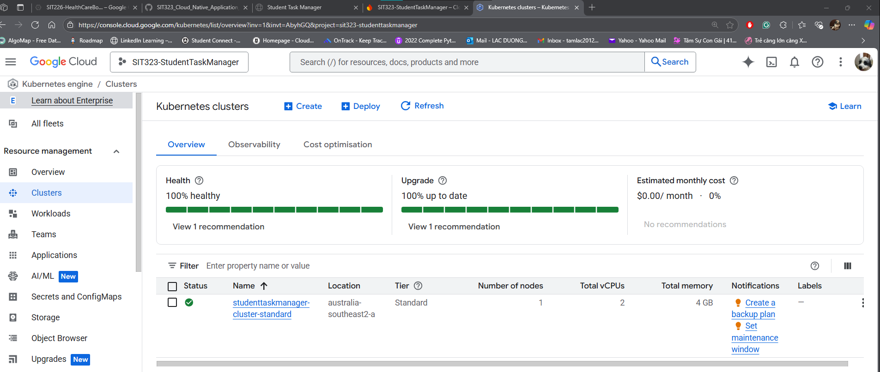

Monitoring with Metric Explorer services (CPU and Memory request utilization)

**Worklog:**

**Week 1 (May 7-13)**

**May 7 - GCP Project Setup and Initial Configuration**

* Created and configured GCP Project (SIT323-StudentTaskManager) for cloud-native development
* Enabled essential Google Cloud APIs:
* Cloud Firestore API for database functionality
* App Engine Admin API for potential future App Engine integration
* Cloud Build API for container image building
* Container Registry API for Docker image storage
* Kubernetes Engine API for container orchestration
* Established Cloud Firestore database in Native mode with appropriate region selection (australia-southeast2)
* Configured initial security rules in test mode to allow development and testing

**May 8 - Backend Integration Setup**

* Created dedicated service account (student-task-manager-dev) for development purposes
* Configured Firebase Admin SDK with appropriate permissions
* Implemented initial Firestore database connection in backend
* Started rewriting backend CRUD operations:
* Implemented task creation endpoint with Firestore integration
* Set up task retrieval functionality

**May 9 - Backend Development Completion**

* Completed implementation of all CRUD operations for Firestore:
* Finalized task update functionality
* Implemented task deletion with proper error handling
* Added data validation and error checking
* Conducted comprehensive testing of all API endpoints using Postman
* Verified data persistence and retrieval accuracy

**May 10 - Containerization Setup**

* Developed Dockerfile with Node.js 18 Alpine base image
* Configured container environment:
* Set up working directory
* Configured Node.js environment
* Set up port exposure
* Created comprehensive .dockerignore file to exclude unnecessary files
* Built initial Docker image locally
* Tested container functionality:
* Verified application startup
* Tested API endpoints within container

**May 11 - Container Registry Integration**

* Configured Docker client for Google Container Registry access
* Set up authentication for GCR
* Tagged Docker image with appropriate versioning
* Pushed image to Google Container Registry
* Verified image availability and accessibility

**Week 2 (May 14-20)**

**May 14 - Kubernetes Cluster Setup**

* Created GKE cluster in australia-southeast2-a region
* Configured cluster specifications:
* Set up node configuration
* Configured network settings
* Established security parameters
* Set up kubectl for cluster management
* Verified cluster connectivity and configuration

**May 15 - Kubernetes Configuration**

* Developed Kubernetes deployment YAML
* Configured pod specifications
* Set up container configurations
* Implemented resource limits
* Created LoadBalancer service configuration
* Implemented Workload Identity for secure GCP service access
* Applied initial Kubernetes configurations

**May 16 - Application Deployment**

* Deployed application to GKE cluster
* Monitored deployment progress and pod health
* Verified service accessibility through LoadBalancer
* Conducted initial load testing
* Troubleshot deployment issues

**May 17 - Frontend Integration**

* Updated frontend code to connect with GKE backend
* Implemented CORS configuration
* Resolved connection and communication issues
* Conducted frontend testing:
* Verified task creation
* Tested task updates
* Validated task deletion

**May 18 - Authentication Implementation**

* Set up Firebase Authentication project
* Implemented user interface components:
* Created login form
* Developed signup interface
* Added user profile management
* Integrated Firebase SDK with frontend application
* Implemented authentication state management
* Added user session handling

**May 19 - Security Implementation**

* Secured backend endpoints with Firebase authentication
* Implemented user-specific task management:
* Added user ownership to tasks
* Implemented task access control
* Developed token verification middleware
* Updated task operations to include user context

**May 20 - Final Testing and Documentation**

* Conducted comprehensive end-to-end testing:
* Tested user authentication flow
* Verified task management functionality
* Validated security measures
* Resolved final authentication and authorization issues
* Prepared final project report

**PowerPoint Slides Link: (**I attached this Slides within the folder of task 10.2HD)

https://github.com/HaydenDuong/SIT323_Cloud_Native_Application_Development/tree/main/Student%20Task%20Manager/documents